Use cases, Queries and Results

1. What user posted this tweet?

**Query:** Select twitter_handle, tweet_text from tweets where tweet_id='1591152363';

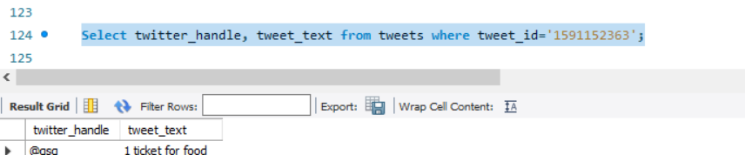

2. When did the user post this tweet?

**Query:** Select twitter_handle, tweet_text, created_at from tweets where created_at ='2008-11-11';

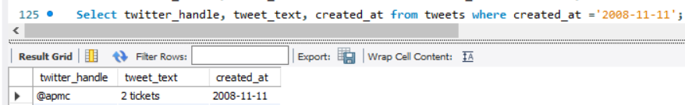

3. What tweets have this user posted in the past 24 hours?

**Query:** Select tweet_id, tweet_text from tweets where twitter_handle='@apmc' and (created_at between (curdate()-1) and curdate());

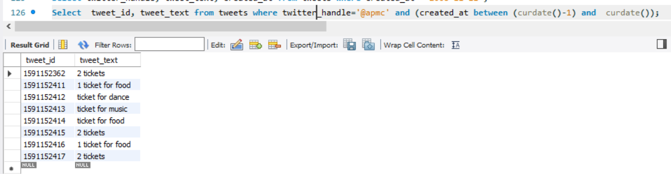

4. How many tweets have this user posted in the past 24 hours?

**Query:** Select count(tweet_id) as NoOfTweets from tweets where twitter_handle='@apmc' and (created_at between (curdate()-1) and curdate());

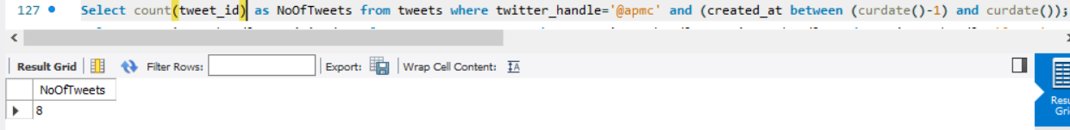

5. When did this user join twitter?

**Query:** Select u.twitter_handle, u.join_date from tweets t, user u where u.twitter_handle=t.twitter_handle and u.twitter_handle='@apmc';



6. What keywords/hashtags are popular?

**Query:** Select hashtags from tweets group by hashtags having count(tweet_id)>10;

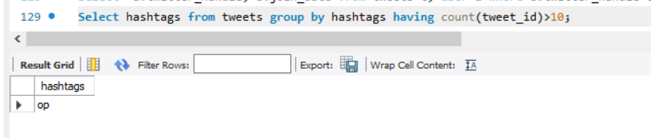

7. Register for an account in Northeastern Events Portal (NEP)

**Query**: Insert into admin (twitter_handle,password) values ('@john', 'john#21');



8. Register for an event

**Query:** Insert into tweets (tweet_id, twitter_handle, tweet_text, created_at) values ('1591152418', '@john', 'I want to buy a ticket for diwali event', '2008-11-12');

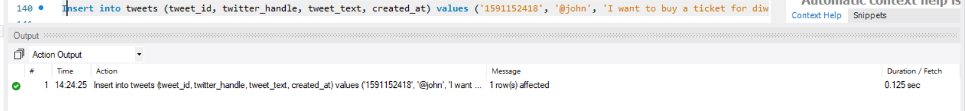

9. View an event already registered through Twitter by a user

**Query:** Select e.event_id from events e, event_tickets t, clubs c, user u where

e.event_id=t.event_id and c.club_id=e.club_id and u.twitter_handle=c.twitter_handle and u.twitter_handle='@apmc';

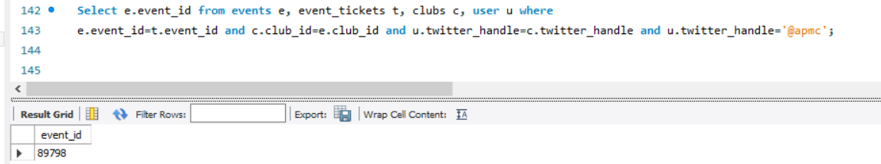

10. View the events happening on a particular date.

**Query**: Select * from events where event_date='2022-08-12';

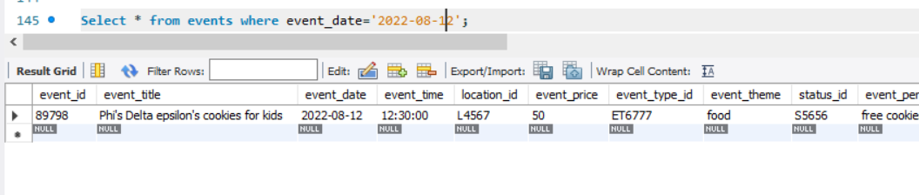

11. View the events that are free or based on event type to attend

**Query**: Select * from events e, event_type t where t.event_type_id=e.event_type_id and t.event_type_name=’dance’ ;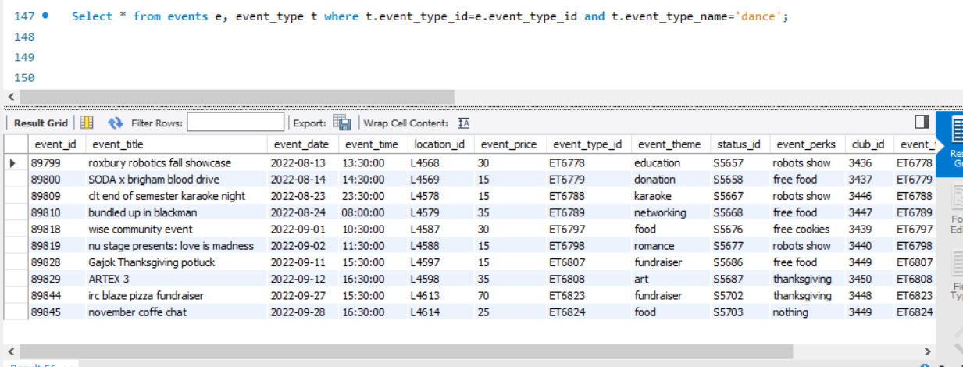

12. View the events that are happening in a location

**Query**: Select street,city,state from events e, location l where l.location_id=e.location_id and l.city='boston';

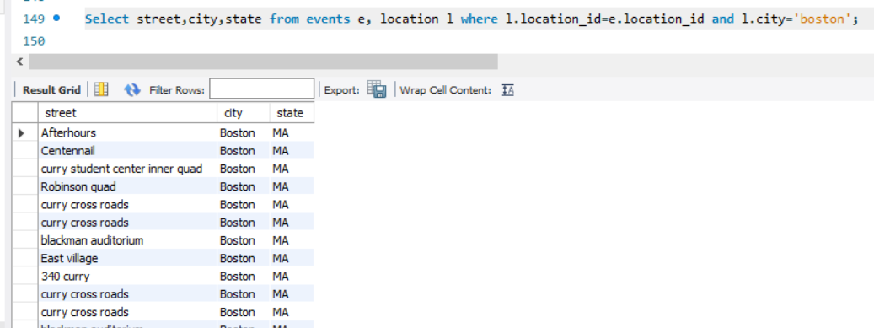

13. View the events that have free perks

**Query**: Select event_id, event_name, event_perks from events where events_perks like ‘%Free%’;

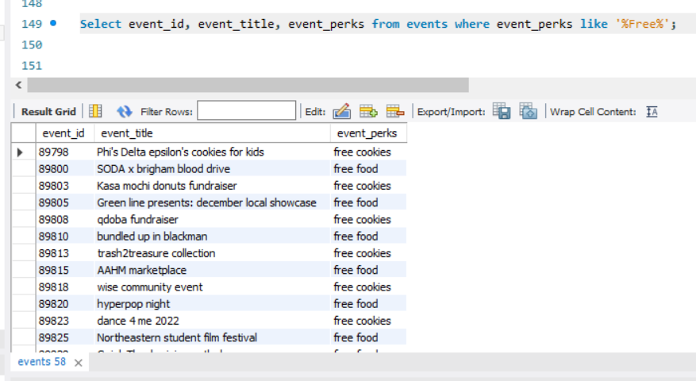

14. View the events that have a particular theme

**Query:** Select event_id,event_name, event_theme from events where event_theme=’networking’;

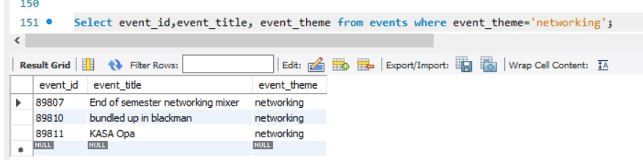

15. View the events that are being organized by a club

**Query:** Select e.event_Id,e.event_title from events e, clubs c where c.club_id=e.club_id and club_name='Fintech Initiative';

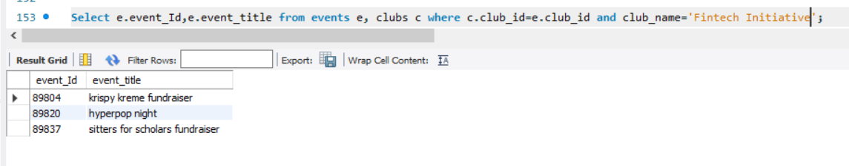

16.  View the payments made by the user

**Query:** Select p.payments_id,p.paid_on,p.total_amount from payments p, user u where u.twitter_handle=p.twitter_handle and u.twitter_handle='@apmc';

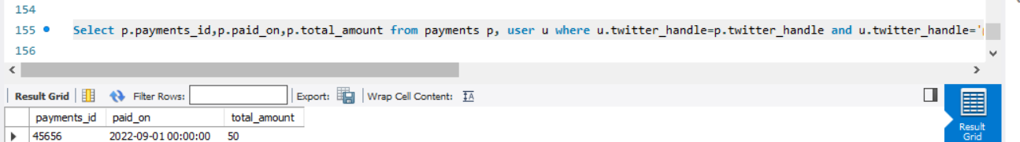

17. View the events that are below a particular price ($20)

**Query:** Select event_id,event_title from events where event_price<20;

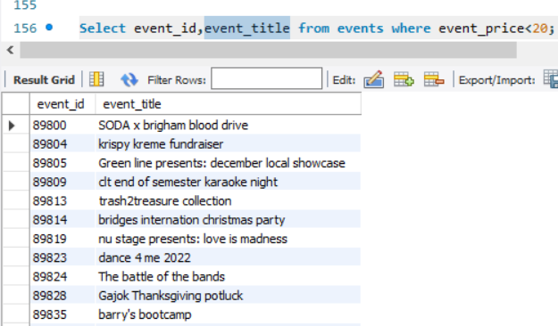

18. View the event status

**Query:** Select e.event_id, e.event_title,  s.event_status from events e, event_status s where s.status_id=e.status_id;

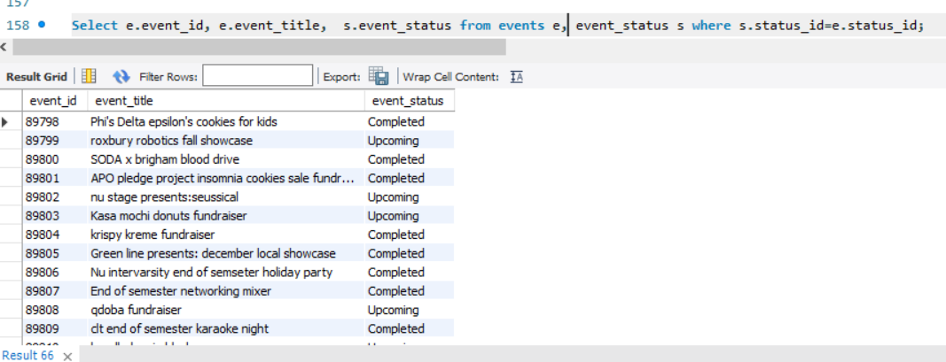

19. View the details of the organizer for an event;

**Query:** Select o.organizer_id, o.first_name from events e, clubs c, organizer o where c.club_id=e.club_id and o.oraganizer_id=c.organizer_id;

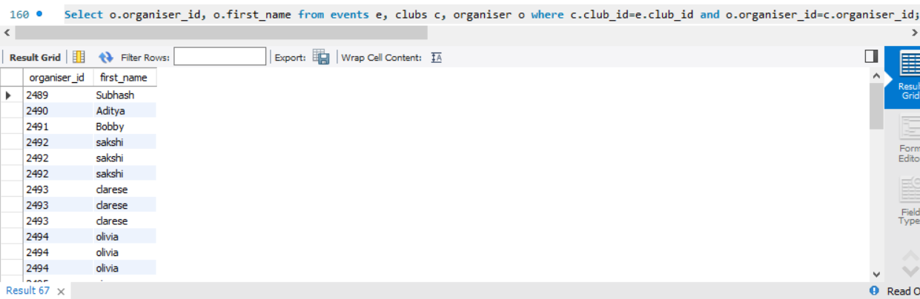

20. View the location of a club

**Query:** Select club_name, club_location from clubs where club_name='Fintech Initiative';

